*Editor>>*

clc;

clear all;

close all;

im1= imread('cameraman.tif'); % Read the image

theta_d=input('Enter the angle of rotation(degree): ');

theta_r=((theta_d*3.142)/180); % Conversion of degree into radian

[m,n]= size(im1); % Number of rows and columns in the image

x_centre=round(m/2); % Centre of the image

y_centre=round(n/2);

for i=1:m

p=x_centre-i;

for j=1:n

q=y_centre-j;

a=p*(cos(theta_r)) - q*(sin(theta_r)); % Origin of the image

b=p*(sin(theta_r)) + q*(cos(theta_r));

a=round(a+ (m/2)+ x_centre); % New Origin of the image

b=round(b+ (n/2)+ y_centre);

im2(a,b)=im1(i,j); % Mapping of the image

im2(a-1,b)=im1(i,j);

im2(a+1,b)=im1(i,j);

im2(a,b-1)=im1(i,j);

im2(a,b+1)=im1(i,j);

end

end

subplot(1,3,1);

imshow(im1); % Show the original image

title('Original');

subplot(1,3,2);

imshow(im2); % Show the image after the rotation

title('After Rotation');

z=imrotate(im1,(360-theta_d)); % By default Anti-clockwise rotation

subplot(1,3,3);

imshow(z); % Show the image after the rotation using function

title('Using Function');

*Command Window>>*

Enter the angle of rotation(degree): 90

*Output>>*

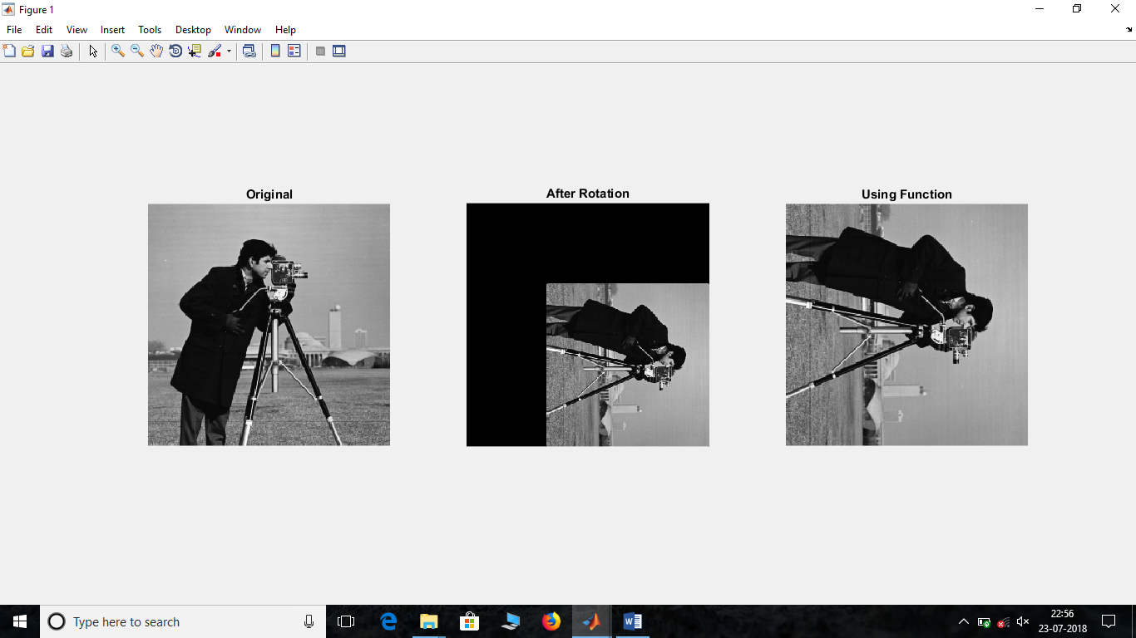

clc;

clear all;

close all;

im1= imread('cameraman.tif');

subplot(2,3,1);

imshow(im1); % Original Image

title('Original');

[m,n]= size(im1);

im1= imread('cameraman.tif');

im1=double(im1); % Conversion into double data type

im2=im1+im1+im1;

im2=uint8(im2); % Conversion into integer data type

subplot(2,3,2);

imshow(im2); % Addition of Images

title('Addition of Images');

im1= imread('cameraman.tif');

im1=double(im1);

s=255*ones(m,n);

im2=s-im1;

im2=uint8(im2);

subplot(2,3,3);

imshow(im2); % Subtraction of Images

title('Subtraction of Images');

im1= imread('cameraman.tif');

im1=double(im1);

im2=im1.*(im1);

im2=uint8(im2);

subplot(2,3,4);

imshow(im2); % Multiplication of Images

title('Multiplication of Images');

im1= imread('cameraman.tif');

im1=double(im1);

im2=im1./(2);

im2=uint8(im2);

subplot(2,3,5);

imshow(im2); % Division of Images

title('Division of Images');

*Output>>*

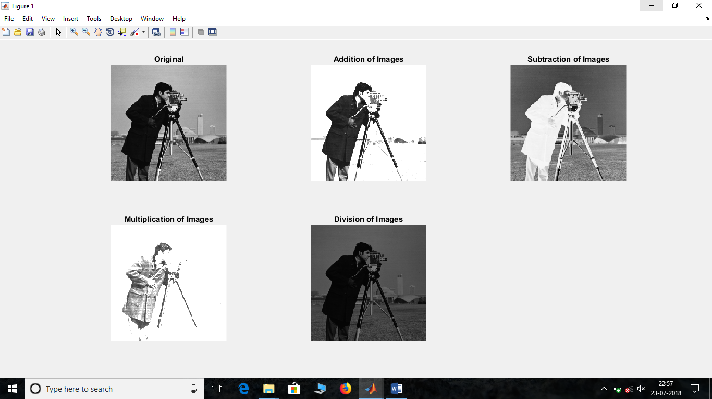

clc;

clear all;

close all;

im1= imread('Q:\SEM 7\DIP\DIPLab_manual_and_images\mask1.bmp');

subplot(2,3,1);

imshow(im1);

title('Image 1');

im2=imread('Q:\SEM 7\DIP\DIPLab_manual_and_images\mask_TR.bmp');

subplot(2,3,2);

imshow(im2);

title('Image 2');

im3=im1 & im2; % Bitwise ANDing

subplot(2,3,3);

imshow(im3);

title('Logical ANDing of Images');

im3=im1 | im2; % Bitwise ORing

subplot(2,3,4);

imshow(im3);

title('Logical ORing of Images');

im3=~im1; % Bitwise NOT

subplot(2,3,5);

imshow(im3);

title('Logical NOT of Image 1');

im3=~im2;

subplot(2,3,6);

imshow(im3);

title('Logical NOT of Image 2');

*Output>>*

